**DEFENCE INSTITUTE OF ADVANCED TECHNOLOGY**

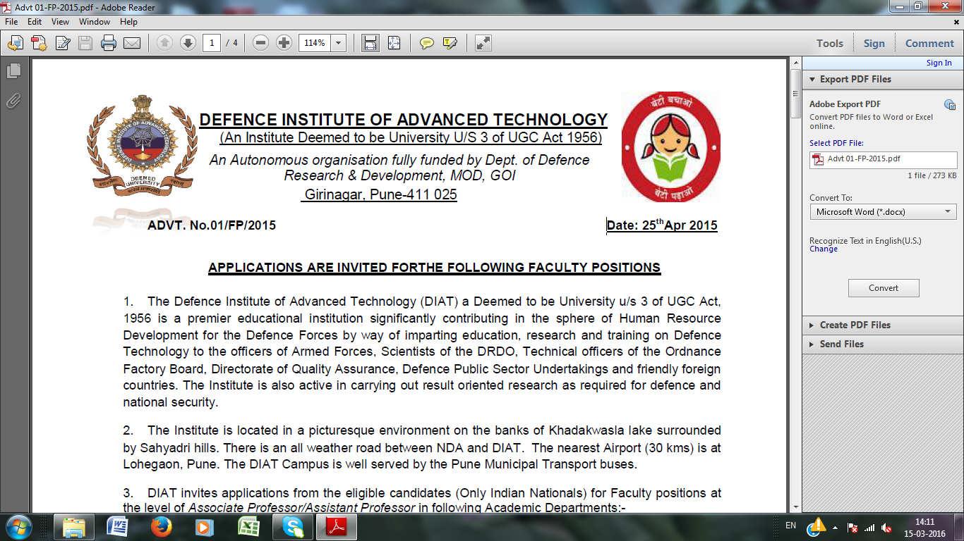

(Deemed to be University U/S 3 of UGC Act 1956)

Girinagar, Pune-411 025

Paste Here a Copy of Your Recent Pass-Port Size Photograph & attest self.

|  |
| --- |
| **FOR OFFICE USE ONLY** |
| **APPL. NO. DATE** |

**Name of the post applied for**:

### Advt. No ____________ Dated:

**GENERAL INFORMATION:**

1. 1. (i) Name in Full : …………………………………………………………….
   1. (ii) if married, maiden name : …………………………………………………………
2. 2. Father’s/Husband’s Name:……………………………………………………………………………..……..

3. Date of Birth : Date…….………….Month………………………..Year……………………..……..

(As recorded in Matriculation or equivalent certificate)

4. Age (as on the last date for receiving of application): ………years………….months ………….days

5. Nationality : ……………………………….

6. Marital Status : Married / Unmarried

7. Sex : Male / Female

8. (a) Category : ST/SC/OBC. If any other, specify………………………

(b) Sub category : PWD(OH/VH/HI)/Ex-Serviceman/Sports. If any other specify?

9. PERMANENT ADDRESS: …….……………………………………………………………………………………………………………

……………………………………………………………………………………………………………………………………………………………………………………………………………………………….…… …………………………………………………………………………………………….……………………

2

10. ADDRESS FOR CORRESPONDENCE: …….……………………………………………………………………………………………………………

……………………………………………………………………………………………………………………………………………………………………………………………………………….………..…………… ………………………………………………………………Email……………………………………… ………………………………………………………………………………………………………………..

Land-line Ph.: ……………………………………….. Mobile ……………………………..…………………..

11. EDUCATIONAL QUALIFICATIONS **(*)** (from Matriculation onwards):

|  |  |  |  |  |  |  |  |  |
| --- | --- | --- | --- | --- | --- | --- | --- | --- |
| Examination | Degree | Board / University | Year of Passing | Marks | | | Class/Grade | Subject(s) |
| Obtained | Out of | % of Marks |
| Matriculation  (10th) |  |  |  |  |  |  |  |  |
| Higher Secondary / Intermediate (12th) |  |  |  |  |  |  |  |  |
| Diploma/ Bachelor’s Degree |  |  |  |  |  |  |  |  |
| Any other Bachelor’s Degree |  |  |  |  |  |  |  |  |
| Master’s Degree |  |  |  |  |  |  |  |  |
| M. Phil./  Ph. D. |  |  |  |  |  |  |  |  |
| Technical Qualifications (if any) |  |  |  |  |  |  |  |  |
| Computer Qualifications |  |  |  |  |  |  |  |  |
| Any other  Qualification (if any) |  |  |  |  |  |  |  |  |

**(Note : (*) Please attach separate sheets if the space is insufficient)**

3

12. EXPERIENCE DETAILS (Starting from the latest):

|  |  |  |  |  |  |
| --- | --- | --- | --- | --- | --- |
| Designation | Name of the Organization/ in case of non- Govt. pl specify. | Salary Details | **Period of Service** | | |
| **From** | **To** | **Total Period** |
|  |  |  |  |  |  |
|  |  |  |  |  |  |
|  |  |  |  |  |  |
|  |  |  |  |  |  |
|  |  |  |  |  |  |

13. ADDITIONAL INFORMATION, IF ANY:

………………………………………………………………………………………………………………………

……………………………………………………………………………………………………………………..

………………………………………………………………………………………………………………………

……………………………………………………………………………………………………………………..

………………………………………………………………………………………………………………………

……………………………………………………………………………………………………………………..

………………………………………………………………………………………………………………………

14. I hereby declare that all entries made by me in this application are true, complete and correct to the best of my knowledge and belief. I understand that in the event of any information being found false, incomplete or incorrect, my candidature/appointment is liable to be cancelled/terminated. I have enclosed attested copies of the supporting documents in respect of Sr. No. 3, 8, 11 and 12 above.

Place………………………………..

Date……………………………….. Signature of the Applicant

(Encl: As above)